Repository Assessment – Collaboration Scenario

Team Number | Name and Employee ID | GitHub URI | BitBucket URI
3 | Nisanth Saravanan  12576  (Team Lead) | - | skyabovesky / collab-scenario — Bitbucket
3 | Terrance Antony Alex  12574  (Collaborator) | - | skyabovesky / collab-scenario — Bitbucket
3 | Tarun Balaji  12569  (Team Lead) | tarunb-0127/team-assesment-repo | -
3 | Arul Begonia  12577  (Collaborator) | tarunb-0127/team-assesment-repo at feature/method2 | -
3 | Madhvan Ramalingam  12592  (Collaborator) | tarunb-0127/team-assesment-repo at Feature/Method1 | -

BitBucket

Team Lead – Nisanth Saravanan

Creating repository:

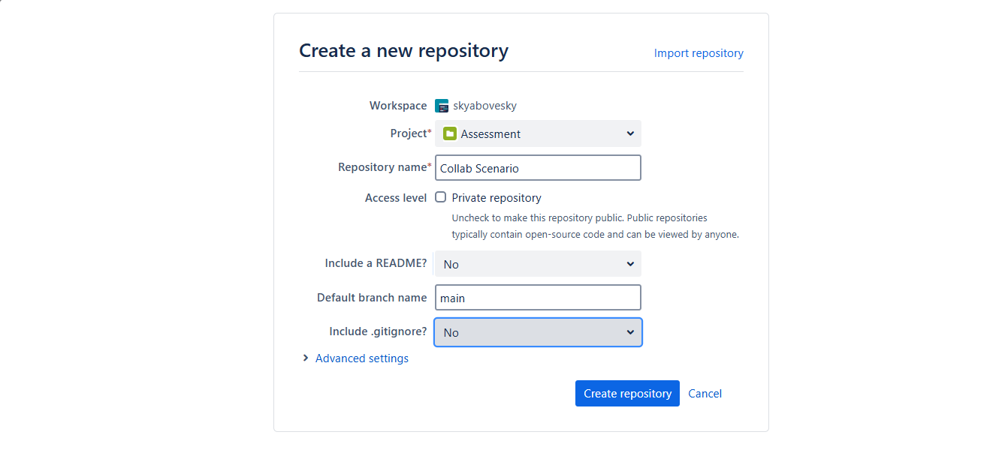

Clone repo:

Add file:

Skeletal file:

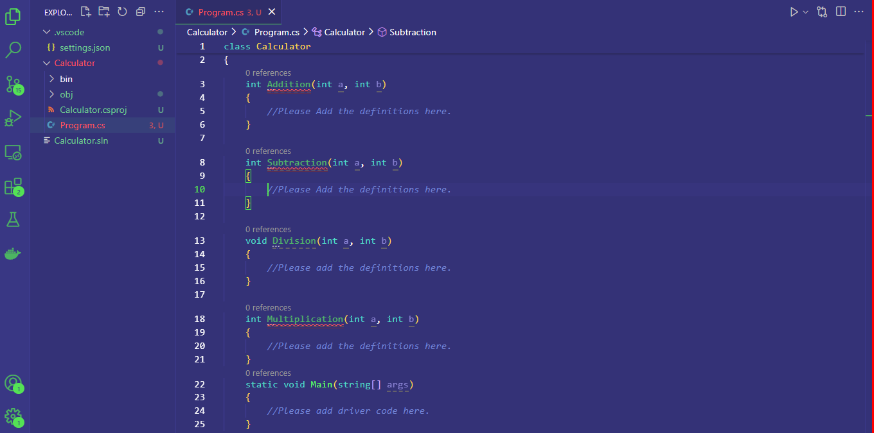

Staging and local committing:

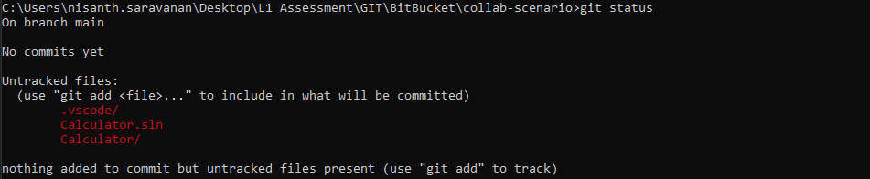

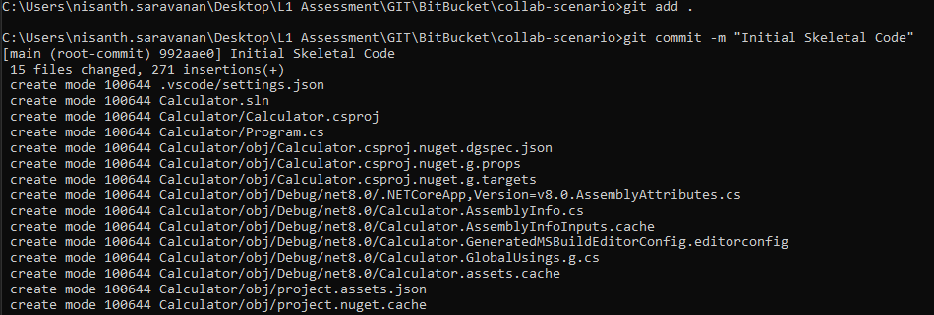

Pushing changes to main:

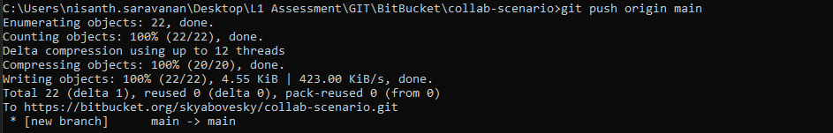

Inviting collaborators:

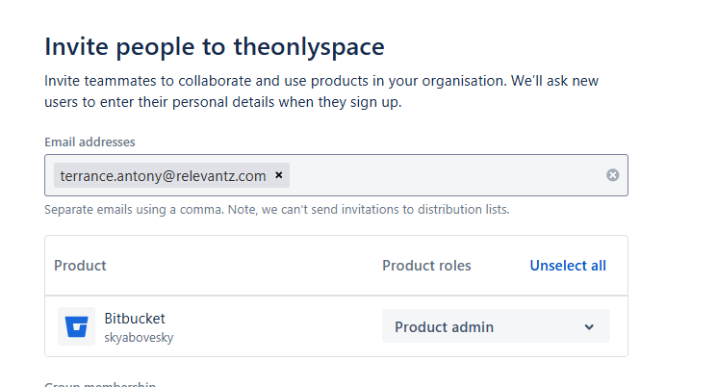

Inviting to Project:

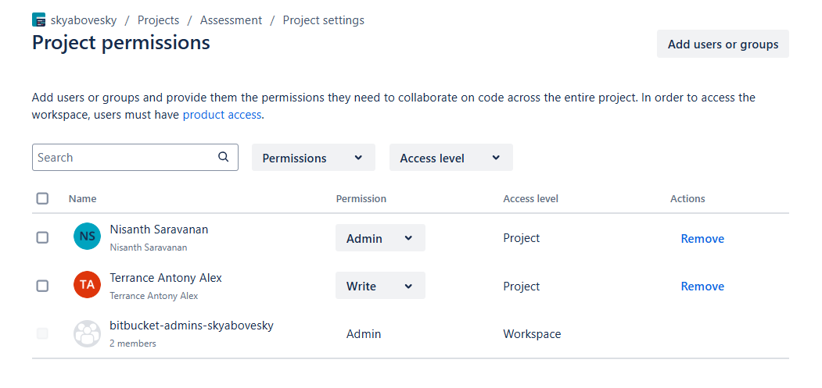

Inviting to Repository:

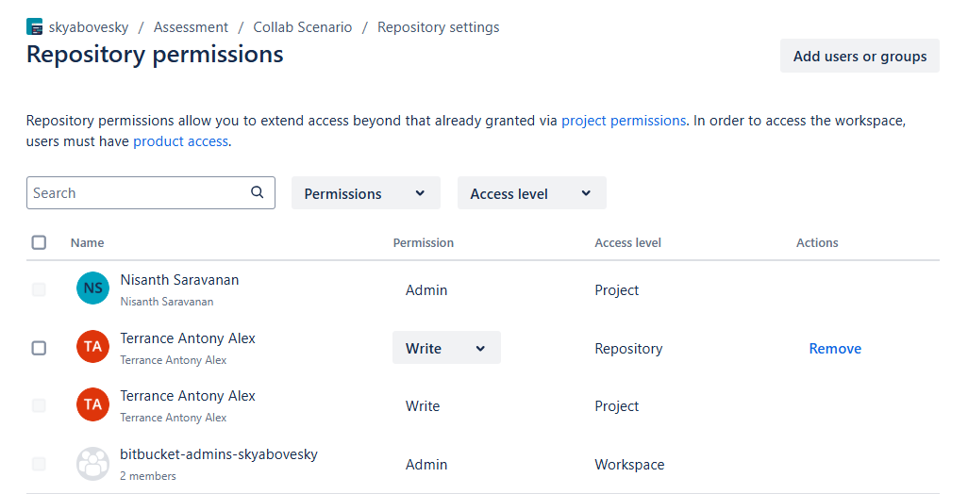

Collaborator – Terrance Antony Alex

Cloning repository:

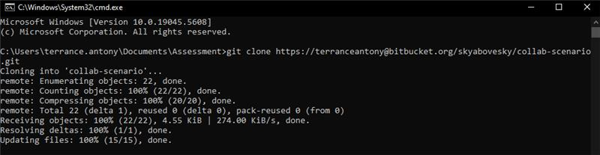

Creating a branch:

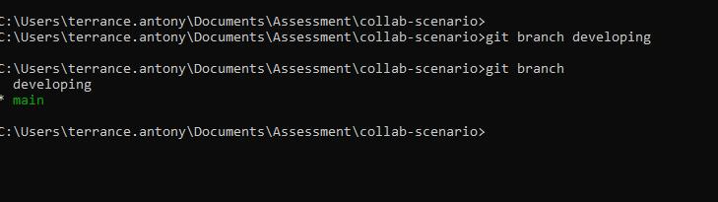

Modifying the skeletal file:

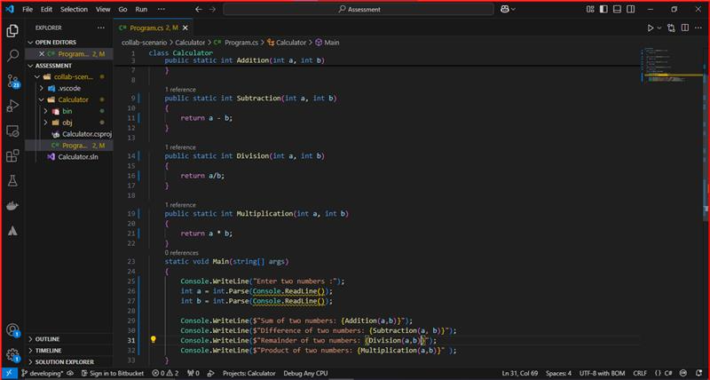

Code output:

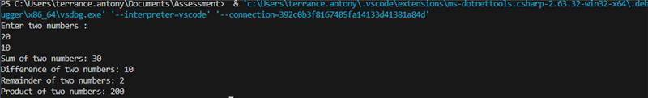

Staging and local commit:

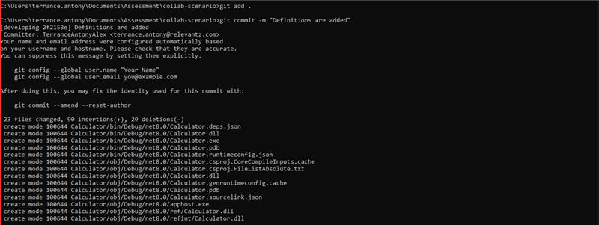

Pushing changes to branch:

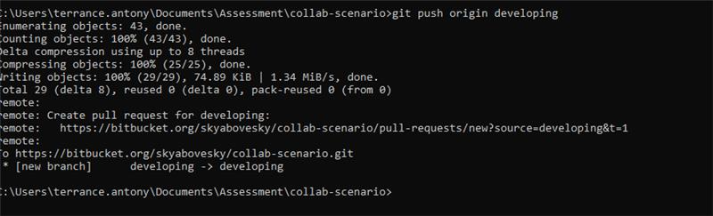

Reflections:

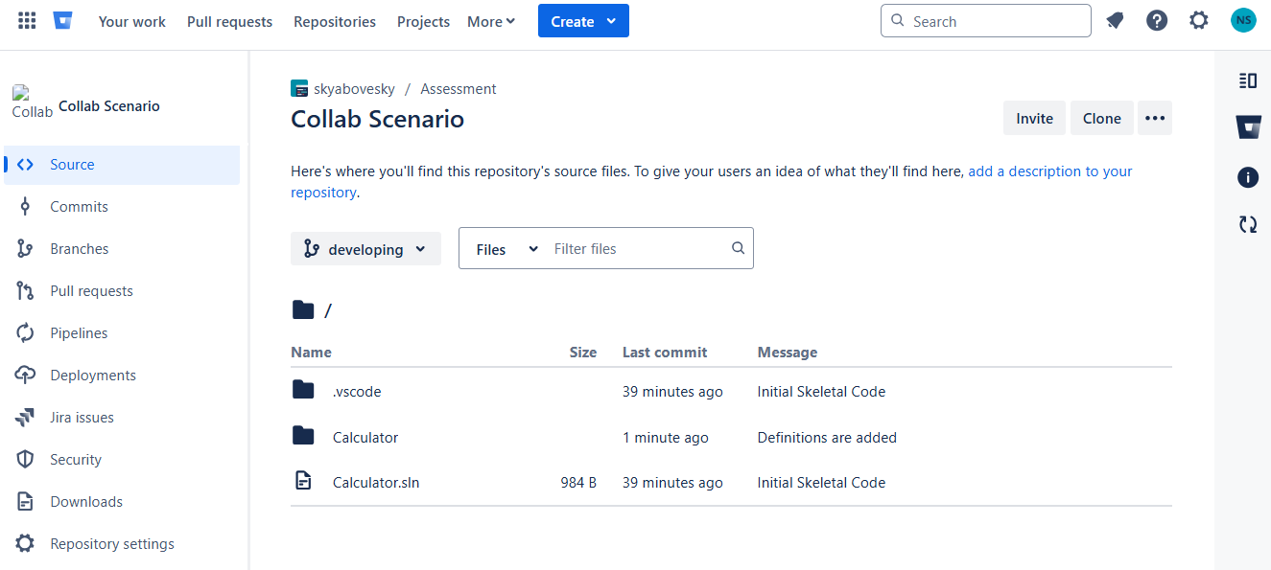

Creating a pull request:

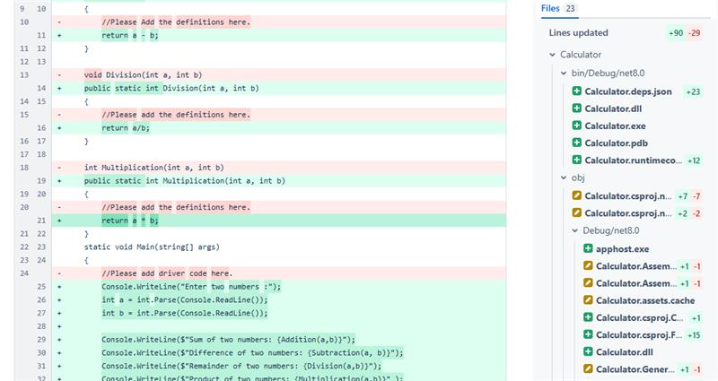

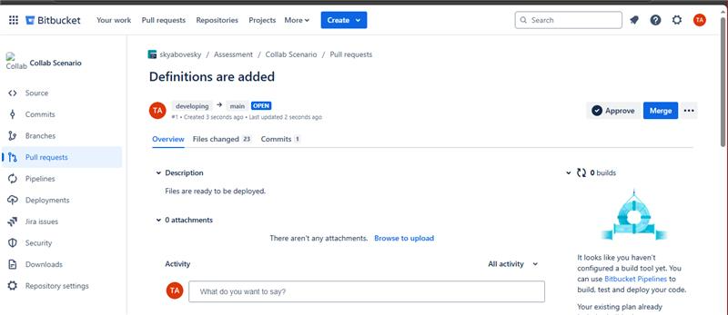

Team Lead – Nisanth Saravanan

Reviewing ans approving request:

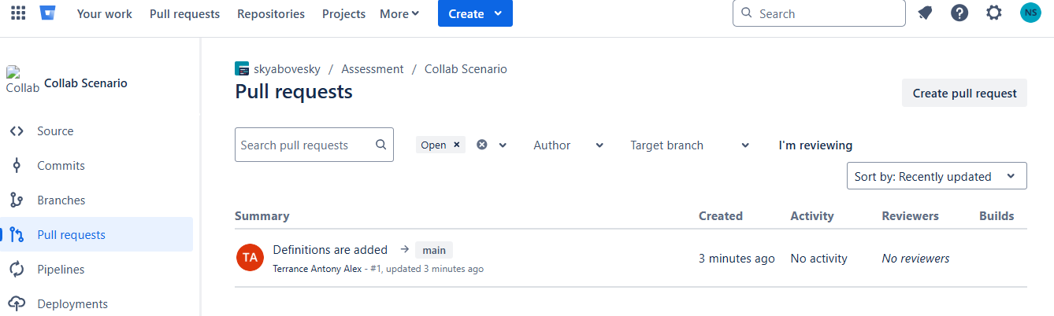

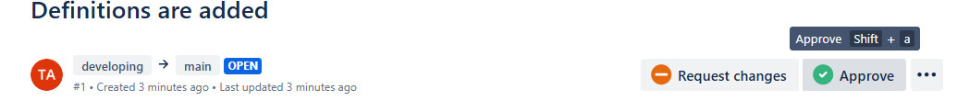

Request approved:

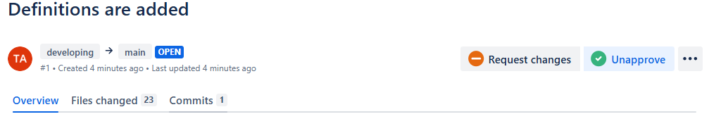

Collaborator – Terrance Antony Alex

After TL approval:

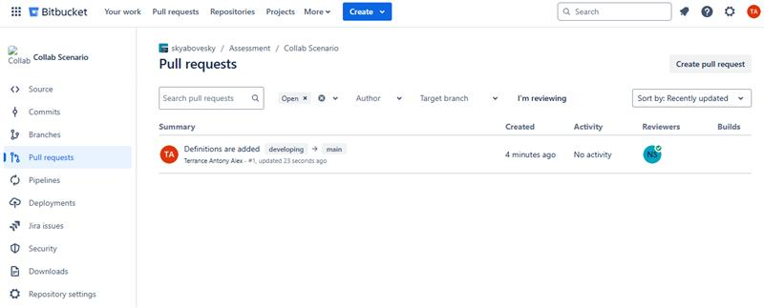

Proceeding with merge:

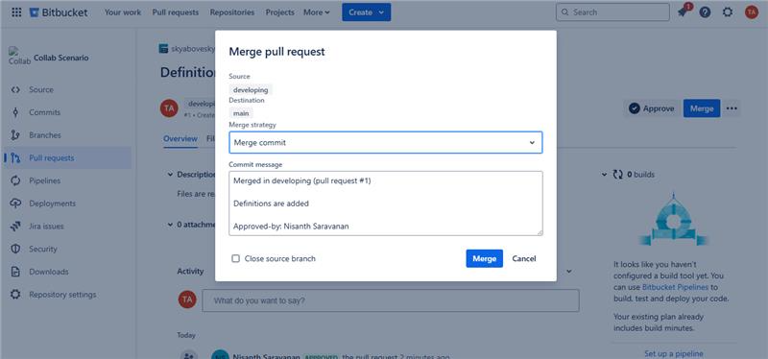

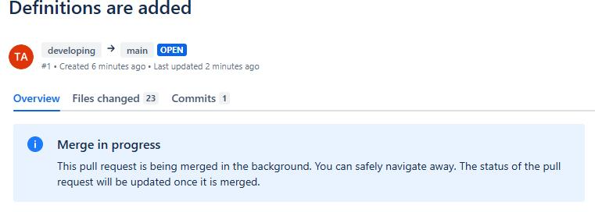
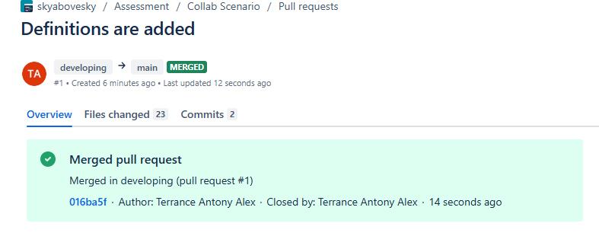

Final reflection in main:

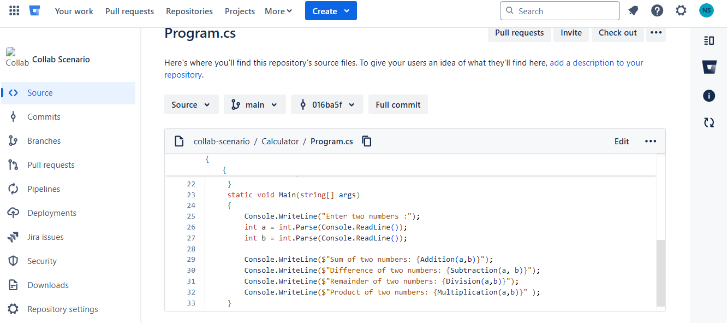

All changes from the branch have been successfully added to the main branch.

